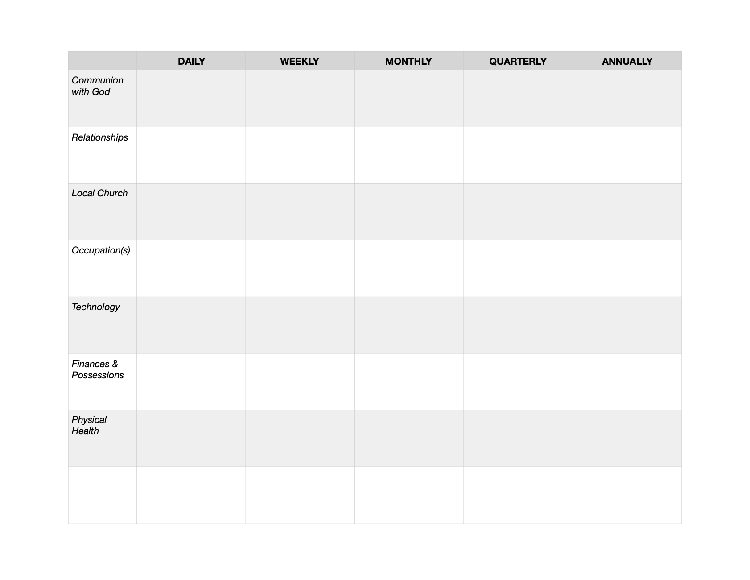
Communion with God
Most of us want a vibrant relationship with God and know it’d be good for us in the long run, but sometimes we leave it up to how we’re feeling on a given day. We can establish practices that help us with this.
Examples: Daily time in Scripture and prayer (may want this be the first thing on your Rule), the daily office (praying at specific times throughout the day), Scripture memory, weekly sabbath, monthly half-day with God, a quarterly or annual day/weekend of solitude
Relationships
We’re invited to love the people around us in increasing measure. What are some habits that help us grow in love for those God has put in our lives?
Examples: Daily 30-minutes of intentional conversation with your wife or roommate, a daily meal together, a weekly phone, FaceTime, or Zoom call with a friend, family member, or accountability partner, monthly connecting with a non-believing neighbor/co-worker to learn how they’re doing, quarterly weekend away with family or annual retreat with friends (plan for post-coronavirus!)
Local Church
God calls us to pursue Him in community, encouraging one another and bringing our gifts, resources, and talents to bless the rest of the body.
Examples: Daily prayer for the church? What weekly or monthly rhythms of serving the church could you engage in? What unique opportunities exist within your Gospel Community?
Occupation(s)
So many of us spend the bulk of our waking hours working a job (for pay or not!). What does it look like to steward our occupations faithfully both to thrive in them and also to not let them take over the rest of our lives?
Examples: Daily, what hours are you trying to work? Any weekly habits specific to your job? A weekly or monthly look at priorities for the coming days; an annual review or reconsideration to see whether God is calling you to continue in this work or not
Technology
This has been a huge blindspot to us because of how rapidly it’s been developed in the last couple decades, but it’s important to be thoughtful around how we use technology rather than allowing it to call the shots in our lives. This is especially true as many of us are confined to our homes right now!
Examples: Daily: What are your limits on phone usage or TV? Maybe plugging your phone in outside your bedroom so it’s not the first/last thing each day (buy an alarm clock!); Weekly: do you have an aim for how much Netflix/TV you consume? (Maybe your Sabbath limits tech, or you quarterly or annually take a more extended break from certain types of technology.)
Finances & Possessions
Jesus has a whole lot to say about money and possessions. He cares about how we steward the resources that have been given to us by God, so what are some rhythms that might be helpful for us to walk in health?
Examples: Some form of daily accountability to a budget, monthly budget meeting, a regular tithe, paying bills, annual taxes, monthly or annual gift to something or someone. You might also ask, How are you taking good care of your house or other assets?
Physical Health
We often forget that God cares a lot about the way we treat our bodies, and it can be really hard to know what truly healthy living is like in our world that’s so saturated with extreme examples of neglect on one side or over-emphasizing health as an idol in itself. But what could increasing faithfulness look like in this area?
Examples: Some kind of daily eating habit, or aiming for a certain number of hours of sleep each night; How much weekly exercise do you want? Weekly What about a monthly meeting with a counselor? Or an annual doctors or dentist appointment (once you can again!)?

